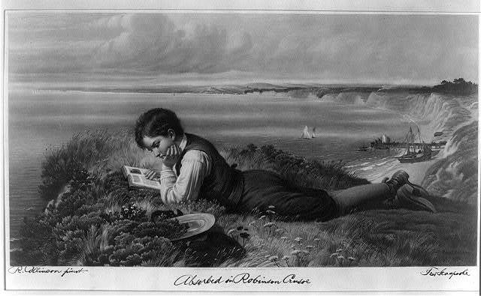
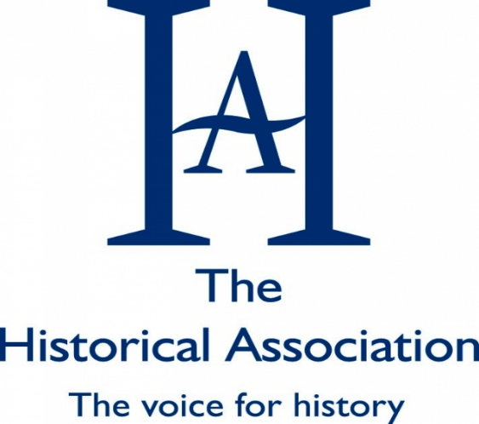
Reading historical fiction

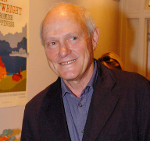
“You can't believe anything that's written in a historical novel, and yet the author's job is always to create a believable world that readers can enter. It's especially so, I think, for writers of historical fiction.”

Justin Cartwright, novelist

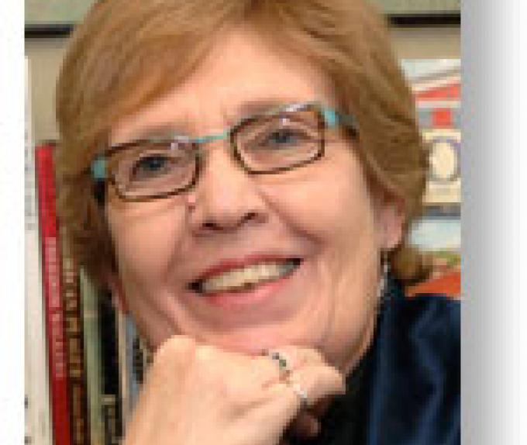
The combination of a good book and factual story can help “embed history in a narrative arc” so that “instead of it being isolated bits of information, it ties together, and the story and the history make a web of meaning for the kids that helps them to remember what they read.”

Linda Levstik, a professor in the University of Kentucky’s Department of Curriculum and Instruction
Historical fiction can take you places!

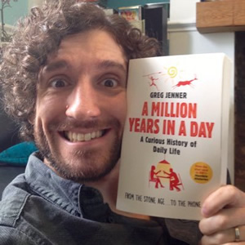
Greg Jenner, celebrity historian and ‘Chief Nerd’ for BBC Horrible Histories says…
“As a boy I was particularly drawn to the excitement of air combat in the two world wars. My grandfather had been in the RAF during WW2 and from that I memorised all the different types of planes in service. This naturally drew me to reading the Biggles books by W.E.Johns, and I particularly enjoyed his stories set in WW1. They were thrilling and full of adventure but also reflected the dangers of early military aviation. I haven’t read any in a quarter of a century, but I still think of Biggles when I see a Sopwith Camel in a museum.”

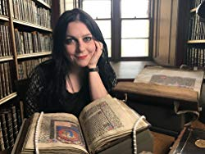
Janina Ramirez, Oxford historian and TV presenter says…
“As far as historical fiction I read as a child, I tended towards the classics …. actually, some of the best fantasy is based on deep historical context - take J.R.R. Tolkein's work for example, which all lovingly cites Early Medieval and Viking culture throughout. But the one I went back to again and again was Enid Blyton's 'Tales of Long Ago.' I had a hard-backed copy and it was a treasure for me. I think it sowed a life-long love of mythology, ancient history and beautiful books!”

Where will historical fiction take you? On the next pages you will find lots of ideas for reading arranged by time period. Do let us know if you find other great books so that we can share them with everyone. You can contact us at: enquiries@history.org.uk

Before 1000
The Boy with the Bronze Axe by Kathleen Fiddler - a catastrophe hits the Stone Age village of Skara Brae in Orkney and buries it under sand until its re-emergence in a storm in 1850.
Warrior Scarlet by Rosemary Sutcliff - In Bronze Age Britain, young Drem must overcome his disability-a withered arm-if he is to prove his manhood and become a warrior.
Mr Kennett, assistant head teacher in Bristol, would recommend any of the Asterix books. “They made me love Ancient Rome.”

The Eagle of the Ninth by Rosemary Sutcliff – ‘Four thousand men disappeared and their eagle standard was lost. It's a mystery that's never been solved, until now…’
Mr Cummings, deputy head teacher in West Yorkshire, says: “Asterix obviously, then The Eagle of the Ninth (such a gripping story) and The Wheel on the School by Meindert DeJong (sort of historical fiction...)”
Mrs G, head of history in London, agrees and loves the Jean Plaidy books too – where can you find them in the list?

The Queen’s Brooch by Henry Treece – ‘The son of a Roman Tribune’s life is changed by his meeting with the warrior Queen Boudicca.’
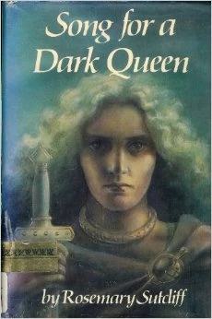
Song for a Dark Queen by Rosemary Sutcliff – the story of Boudicca and the Iceni tribe versus the Romans through the eyes of her loyal servant.
The Shield Ring by Rosemary Sutcliffe - Viking resistance to the Norman Conquest set in and around Buttermere.
Warriors of Alvna by N.M.Browne – two pupils, transported back in time to the year 75 AD in Roman Britain during a school trip, discover that they have acquired extraordinary powers that are to be used to help a Celtic tribe battle against the brutal Romans.
Ruth Dixon, lecturer at Oxford University and a Parliamentary Academic Fellow, recommends: The Ship that Flew by Hilda Lewis- four children travel through time in a magical ship belonging to the Norse god Frey. "She is made of thousands of little pieces fitted together with such cleverness that when she is not wanted Frey can fold her up and put her in his pocket."

Power and Stone by Alice Leader – it is 130 AD on Hadrian's Wall, just as work on the wall is nearing completion. Two boys join their father, a Roman commander, in one of the forts.
The Capricorn Bracelet by Rosemary Sutcliff – a set of stories set at the time of the Roman occupation of Britain and following the fortunes of one family over three hundred years.
Frontier Wolf by Rosemary Sutcliff - as punishment, a young, inexperienced Roman army officer is sent to Northern England to assume the command of the Frontier Wolves.
The Lantern Bearers by Rosemary Sutcliff - the last of the Roman army have set sail and left Britain for ever, abandoning it to civil war and the threat of a Saxon invasion. Aquila deserts his regiment to return to his family, but his home and all that he loves are destroyed.
Outcast by Rosemary Sutcliff - rescued as a baby from a shipwrecked Roman galley, Beric is raised in a British tribe but is never fully accepted by them.
The Silver Branch by Rosemary Sutcliff - in fear for their lives a tattered band of men gather together to defend the honour of Rome. But will they be in time to save the Emperor?
Dawn Wind by Rosemary Sutcliff – ‘The boy lay in the silence of the great battlefield … he realised, with something like surprise, that he was not dead. His name was Owain and further up the hillside lay his father and brother, both killed by Saxon warriors…’
Riddle of the Runes by Janina Ramirez – ‘Alva rushes through the trees in the dead of night with her sniffer wolf, Fen. … What Alva discovers raises more questions than it answers, drawing her into a dangerous search for truth, and for treasure.’
The Short Knife by Elen Caldecott – in 454 Mai has been kept safe, but then the Saxon warriors arrive at their farm and Mai and her family must flee to the hills.
The Yelling Stones by Oskar Jensen - Viking Princess Astrid resists her brother’s attempts to bring Christianity to Denmark in 958.
The Sea of Trolls by Nancy Farmer - Jack is kidnapped by berserkers from his Saxon village in the year A.D. 793, an occurrence forewarned by his mentor the Bard. Captured by Viking chief Olaf One-Brow, Jack and his sister, Lucy, are swiftly taken to the court of Ivar the Boneless.
The Raven & the Cross by John Tully - about Vikings in Britain in the time of King Alfred.
The Viking Saga by Kevin Crossley-Holland - a trilogy of Viking stories written by an excellent story-teller.

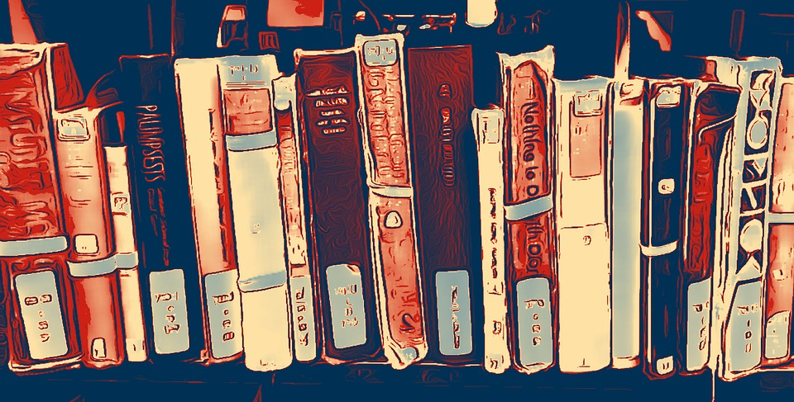
1000-1500
Anglo-Saxon Boy by Tony Bradman - a story of 1066 woven around Magnus, young son of the Earl of Wessex.
Knight’s Fee by Rosemary Sutcliff - against the violent and turbulent backdrop of Norman England, the story of a young boy who is wagered and won in a game of chess between a lord and a minstrel…
Arthur: The Seeing Stone by Kevin Crossley-Holland – 1199, the Welsh Marches, young Arthur de Caldicot has a magical shining stone that reveals King Arthur. The secrets and mysteries of life on a medieval manor are echoed and anticipated by the young King’s story. It is followed by At the Crossing-Places and King of the Middle March set against the backdrop of the Crusade. There is also a spin-off called Gatty’s Tale.
Mr Werner-Meanwell, a history teacher in Bristol, recalls: “The adventures of Robin Hood by Roger Lancelyn Green is a brilliantly readable retelling of the classic tale of taking from the rich and giving to the poor set in the context of Richard the Lionheart’s England, the reign of King John and the era of the Crusades.”

Red Towers over Granada by Geoffrey Trease – set in England and Islamic Spain, it is 1290, a boy is declared a leper, a Jewish doctor is to be expelled from England, a Queen is in need.
Fire, Bed and Bone by Henrietta Branfield - a story set at the time of the Peasants’ Revolt. The narrator is a dog, who witnesses what happens to his family as the drama unfolds.
The Great Revolt by Paul Dowswell – in 1381 Tilda and her father travel to London with the others to petition the king, but the peaceful rebellion they hoped for soon ignites into violence, mayhem and treachery.
Ms Wakeford, a history teacher in London, enjoyed: “Katherine by Anya Seton, which tells the story of the love affair between Katherine Swynford and John of Gaunt. I loved it as a teenager because it was terribly romantic, a real page turner.”

Sun of York by Ronald Welch - a young boy seeks a lord and finds himself living and fighting in the Wars of the Roses.
The Midwife’s Apprentice by Karen Cushman - a young girl is apprenticed to a midwife and medieval village life provides the backdrop.
Warrior Girl by Pauline Chandler - France 1428. Mariane's parents have been murdered by the occupying English army. … Taken in by her aunt and uncle, Mariane is drawn to her strange and awkward cousin, Jehanne.
Sparrow: The Story of Joan of Arc by Michael Morpurgo - Eloise has always loved Joan of Arc. And on a bright sunny day in Orleans, Eloise has a very special daydream…
The Woolpack by Cynthia Harnett - a Cotswold boy and the girl his family intend for him to marry foil a scam by bankers to ruin wool merchants by destroying their reputation with the Calais Staple in the reign of Henry VII. The Woolpack is a favourite for Professor Helen Nicholson who loved it as a child “because it read as authentic history and painted an utterly convincing picture of its age, but was also an edge-of-the-seat adventure story.”

A Little Lower than the Angels by Geraldine McCaughrean - Gabriel runs away from his apprenticeship and playmaster Garvey, has plans for him. He wants Gabriel for his angel...
The Children’s Crusade by Henry Treece – two children made slaves in Egypt have many adventures trying to get home to England.
Good to know…
The series called ‘History Quick Reads’ is great for people looking for short stories from the past that are easy to get into and through.
Catherine, Called Birdy by Karen Cushman - Catherine's father is trying to marry her off to disgusting old Shaggy Beard, and her mother's determined to turn her into the perfect medieval lady…
Robin of Sherwood by Michael Morpurgo - beneath the roots of a great oak tree a boy finds a hunting horn, bones and a skull. Clutching these objects, he has a dream and relives Robin's story.
Katherine Burn, Associate Professor of Education at the University of Oxford, shared “I was totally gripped by the science fiction books by Connie Willis. They are set in a future when Oxford University students learn about the past by travelling back in time. The first in the series – The Doomsday Book – charts what happens when things go wrong with the co-ordinates for a planned visit to 1320 and instead take the history student Kivrin back to 1348 when the Black Death was sweeping England. Later novels Black Out and All Clear involve travel back to London during the Second World War. The plotting is excellent and the details of how the students have to prepare for their travel make it very clear just how different the past is from the present (or, indeed the imagined future!)

Castle Diary by Richard Platt - sent to his uncle's castle to learn to be a page, eleven-year-old Toby keeps a detailed journal of everything that happens there during the year of 1285
The Cousin’s War by Philippa Gregory – a whole series of historical fiction books written for adult readers set in the period of the Wars of the Roses. Great for sense of period for A Level!
Eliza Rose by Lucy Worsley- the story of a young girl in the court of Henry VIII at the time of Anne of Cleves and her cousin, Katharine Howard.
Wolf Hall by Hilary Mantel – award winning historical fiction written for adults centred on the life of Thomas Cromwell, Chief Minister to Henry VIII. The sequels are Bring up the Bodies and The Mirror and the Light

Stop! Think!! What is historical fiction? Isn’t ‘real’ history better than fiction? Should students in history classrooms be working with fiction? Where is the boundary between historical fiction and fantasy? … Aren’t these questions for my history teacher??
Well, let’s start with that easy last one… NO! Why should your history teacher be the only person who can think about such an interesting topic? (They can look at Teaching History 169 ‘Mummy, Mummy!’ article for a summary of these ideas.)
When putting together this guide to historical fiction this really interesting quote attracted attention: “He referred to his research. I referred to my research. He wasn’t convinced. I suggested that the demands of history and fiction are slightly different – that since a novel is a story, it must be complete, and since a history must be accepted by the reader as accurate, it must be incomplete.” It’s from an article by Jane Smiley and you can find it here: https://www.theguardian.com/books/2015/oct/15/jane-smiley-niall-ferguson-history-versus-historical-fiction.
Hilary Mantel is a prize-winning writer of historical fiction. In 2017 she was asked to give the famous and influential annual BBC Reith lectures. You can listen to what she had to say and read more here: https://www.bbc.co.uk/programmes/b08vkm52 There is food for much thought!
What should have been included that is not here? At the start of this booklet, Janina Ramirez refers to early Medieval culture. She is right that Tolkein could not have written his fabulous fantasy books, including ‘The Lord of the Rings’ without his deep knowledge of that past. The 9th century epic poem ‘Beowulf’ is often quoted by historians as a source. We haven’t included it as it is fiction; but we’ve included Asterix. Have we made a mistake? Where would you draw the line to decide what to include if you were making this booklet?

1500-1700
The Prince and the Pauper by Mark Twain – Edward Tudor, heir to the throne, and Tom Canty, a poor boy, change places.
Voices: Diver's Daughter: A Tudor Story by Patrice Lawrence – Eve and her mother, stolen from her family in Mozambique, leave the Elizabethan slums of London to travel to Southampton and to be free-divers on the wreck of the Mary Rose.
A Traveller in Time by Alison Uttley - a young girl lives in the manor of the Babingtons and travels back to the time when the family is caught up in plots to free Mary Queen of Scots.
Kings of Shadows by Susan Cooper - a boy from New England rehearses for a performance of Shakespeare’s a Midsummer Night’s Dream in London and finds himself back in time in the actual Globe with a case of mistaken identity.
The Fool’s Girl by Celia Rees - Violetta and Feste have come to London to rescue the holy relics taken from the church in Illyria by the evil Malvolio. They meet William Shakespeare.
The Goldsmith’s Daughter by Tanya Landman - the story of a young girl struggling to change the course of her fate as the once mighty Aztec Empire collapses around her.
Mr Thornton, a head of history in Cheshire, remembers this book as simply ace! Cue for Treason by Geoffrey Trease - boy from Cumberland throws a stone at local gentry during an anti-enclosure protest. He flees and joins a troupe of travelling actors with Richard Burbage, then part of Cecil’s spies, and helps foil plot against Elizabeth I.

A Skinful of Shadows by Frances Hardinge – a young girl at the time of the English Civil War fears possession by a ghost or death.
Mark of the Plague by Kevin Sands – a crime thriller at the time of the 1665 London plague.
Children of Winter by Berlie Doherty – will they survive the plague?
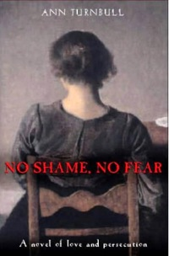
Ghost Hawk by Susan Cooper - a tale of the European colonisation of Massachusetts from the Indians' point of view.
Witch Child by Celia Rees - A young girl watches her grandmother hanged as a witch in 17th century England and escapes to New England, where she must face the dangers of judgement by Puritans. It has a sequel called Sorceress.
No Shame, No Fear by Ann Turnbull - set in England in the 1660s, this is a love story between a Quaker girl and a non-Quaker boy and the persecution they face.

Mrs Wilson from Lincolnshire and she loves using historical fiction with her students.
“I use an extract from Michael Morpurgo - Shadow when looking at modern day migration. I also love the Caroline Lawrence series on Roman Britain - Escape from Rome. I use these with Yr 10 and Yr 7. Also for GCSE CJ Sansom’s historical detective Shardlake (great for getting to grips with Tudor law and order). For post 1900 I use Sashenka by Simon Sebag Montifiore for Russian Revolution and Helen Dunmore The Siege for work on the siege of Leningrad.”

Jason Todd, from the Department of Education, at the University of Oxford has contributed many good books to this list and is also interested in books that engage with meditations on the writing of history. He suggests Waterland by Graham Swift, Moon Tiger by Penelope Lively and History of the world in 10½ chapters. “And”, in his words, “even 1066 and all that” Which is one of those books that is funnier the more you know. Written nearly 100 years ago, it pokes fun at the history learnt in schools and the history lessons we remember from school days.

Senior examiner Mr Harris recommends Simon by Rosemary Sutcliff – two close friends find themselves on opposite sides in the English Civil War. Staff from the Sheffield Community Academy agree – it has inspired a love of teaching the history of the 17th Century.

History and RE teacher Ms Harty grew up in Lancashire close to where the story Mist Over Pendle by Robert Neill is set, telling the story of the Pendle Witches.
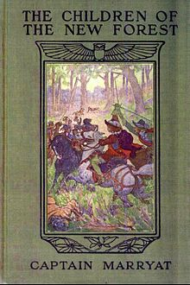
Black Hearts in Battersea by Joan Aitken – Simon wants to be a painter. Then he discovers a plot to kill the King, is kidnapped and meets two stowaways. Together can they save the King in time?
The White Phoenix by Catherine Randall - London, 1666. Lizzie’s father dies and she and her mother take over the family bookshop in the shadow of St Paul's Cathedral.
The Popinjay Mystery by Geoffrey Trease – Charles II is on the throne and highwaymen are more than they seem.
Trumpets in the West by Geoffrey Trease - Somerset boy Jack Norwood loves music, but he is threatened with a career in the wine trade instead.
The Ghost of Thomas Kempe by Penelope Lively - Thomas Kempe the apothecary has returned as a ghost and he wants James to be his apprentice.
Fida Raizada recommends a childhood favourite, Children of the New Forest by Captain Marryat. In it the English Civil war rages and four orphans face adversity, survival in the forest, reconciliation, and eventual forgiveness.

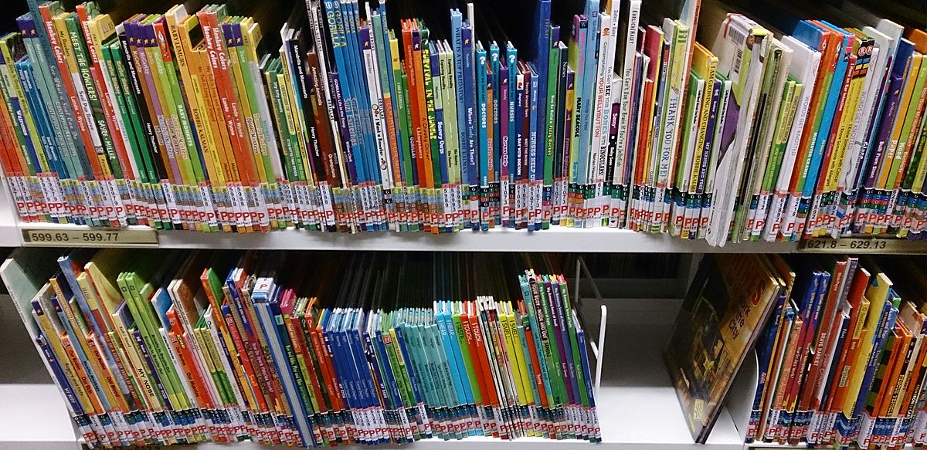

1700-1900
Pirates by Celia Rees - when two young women meet under extraordinary circumstances in the eighteenth-century West Indies, they are unified in their desire to escape their oppressive lives.
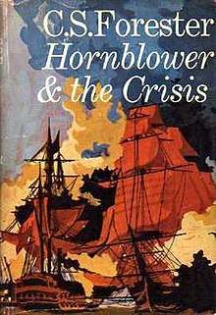
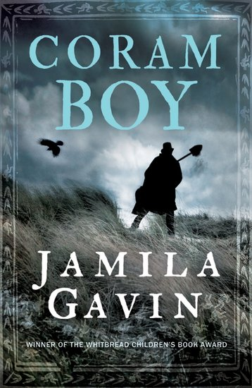
The Three Musketeers by Alexandre Dumas – a classic tale about young D'Artagnan and inseparable friends, Porthos, Athos and Aramis, at the time of Louis XIV of France. Hornblower by CS Forester - there are actually many classic tales of Horatio Hornblower and his life at sea with the Royal Navy.

Coram Boy by Jamila Gavin - set in 18th century England, a story of two boys whose lives become entwined in the time of Thomas Coram’s Foundling Hospital and Handel’s Messiah.
Cane Warriors by Alex Wheatle - based on the true story of Tacky’s Revolt. Teenage Moa is a ‘cane warrior’ fighting for freedom from the Jamaican plantations.
The Apprentices by Leon Garfield - life in 18th century London from the perspective of young boys trying to learn a trade.
Incomparable World by Si Martin - Set just after the American Revolution three African Americans find themselves in Georgian London. It outlines the grim underside of late 18th-century London.
John Diamond by Leon Garfield – a young boy braves London to try to correct the wrong his father did to his business partner.
Sawbones by Catherine Johnson - sixteen-year-old Ezra McAdam has much to be thankful for: trained up as an apprentice by a well-regarded London surgeon, Ezra’s knowledge of human anatomy and skill at the dissection table will secure him a trade for life.
The First of Midnight by Marjorie Darke - tells the experiences of an enslaved person and a bondservant in 18th century England.
Sovay by Celia Rees - wild and beautiful, spoilt and wilful, Sovay finds that her cosseted upbringing in rural England has not prepared her for life as a highway robber.
Freedom by Catherine Johnson - 12-year old Nathaniel is a slave, sent to England. Life in London is tough and Nat seizes the first opportunity to escape. He hears the story of The Zong, a ship where the crew murdered 133 slaves.
Blade and Bone by Catherine Johnson - Ezra McAdam his friend Loveday Finch and her charge the Ottoman Prince Mahmoud are caught up in the revolutionary events in Paris.
The Tale of Two Cities by Charles Dickens – a classic set against the backdrop of France before and during the Revolution that began in 1789.
Mademoiselle Revolution by Zoe Sivak - the story of a biracial heiress who escapes to Paris when the Haitian Revolution burns across her island home.
Are they historical fiction? Who cares!
We recommend Middlemarch by George Elliot for the period of the 1832 Great Reform Act, Mary Barton by Elizabeth Gaskell for life in Manchester in the 1840s and Les Miserables by Victor Hugo for life in Paris in the 1930s. Don’t neglect the classic novels as a way to get a great sense of period, as well as to connect with your literary heritage!

If you were Italian you would study this book in school (obviously in the Italian original!). It’s set in 17th century Italy and was written in the 19th century. It was so important that it shaped the Italian language that is spoken today. Manzoni was so important that the famous composer Verdi wrote a Requiem for him that is still often sung today.
What other great historical novels are there from beyond the UK… ‘The Tin Drum’ by Gunther Grass, ‘The Grapes of Wrath’ by John Steinbeck, ‘The Color Purple’ by Alice Walker, ‘Disgrace’ by JM Coetzee... There are so many!!
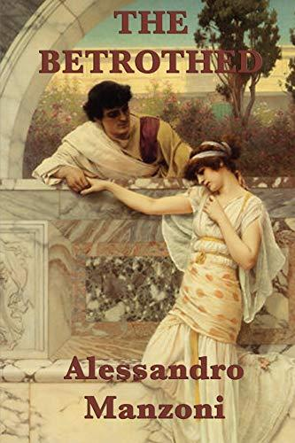
The Slave Dancer by Paula Fox - Jessie Bollier plays his fife on the docks of New Orleans until he is kidnapped and thrown aboard a slave ship, where his job is to provide music while shackled slaves "dance" to keep their muscles strong and their bodies profitable.
English Passengers by Matthew Kneale – a story set against the invasion of Tasmania by British settlers.
Moonfleet by JM Falkner - orphaned John Trenchard grows up in the village of Moonfleet with his aunt. While conducting his own hunt for the treasure, John is trapped in the church crypt and discovers the true secret of the village: smuggling.
Mrs Smee, Head of Humanities in Bristol, loved reading the Scarlet Pimpernel by Baroness Orczy. “Wonderful stuff, dashing heroes, courageous heroines, dastardly evil baddies, historical French Revolutionary nonsense. Loved it!”
Liberty's Fire by Lydia Syson - the streets of Paris during the French Commune in 1791. Two young people, who both believe in a free country, fall in love with each other while a siege from within is starting.
The Curious Tale of the Lady Caraboo by Catherine Johnson - a mysterious tale of a cobbler’s daughter from Devon who fooled the British establishment in the early 19th Century.
Homegoing by Yaa Gyasi – Half-sisters, who don’t know they are related, and their descendants are the subject of this novel that starts in the times of enslavement in the USA and the slave trade on the Gold Coast of Africa and then moves towards the present.
Under the Hawthorn Tree: Children of the Famine by Marita Conlon-McKenna - Ireland in the 1840s is devastated by famine. When tragedy strikes their family, Eily, Michael and Peggy are left to fend for themselves.
Wildflower Girl: Children of the Famine by Marita Conlon-McKenna - at seven, Peggy made a terrifying journey through famine-stricken Ireland. Now thirteen, and determined to make a new life for herself, she sets off alone across the Atlantic to America. Will she ever see her family again? The final book in the Famine series is Fields of Home.
Mr Harris, senior examiner also suggests The Midnight Folk by John Masefield (a former Poet Laureate).” It is set in about 1890 (no cars; traditional gentry) but the boy hero is searching for the treasure his great grandfather (a sea-captain in the days of sail) had lost. Really a "fantasy" but chock full of history.”

Lizzie’s Wish by Adèle Geras - on an extended visit to her cousins in London, Lizzie's passion for plants and trees is fuelled by visits to the newly opened Kew Gardens. Lizzie has ambition and the will to go against the conventions of her Victorian peers.
Passing for White by Tanya Landman - It's 1848 in the Deep South of America. Rosa is a slave but her owner is also her father and her fair skin means she can 'pass for white'. With the help of her husband Benjamin, she disguises herself as a young southern gentleman…
Long Journey Home by Julius Lester – stories of black people whose lives were transformed by slavery.
Little House of the Prairie by Laura Ingalls Wilder – the famous first tale in a series about a family of settlers on the prairies of the USA.
The Birchbark House by Louise Erdrich – the same slice of history written about by Wilder, but through the eyes of Omakayas, sole survivor of a smallpox epidemic on Spirit Island. It is the first in a series with The Game of Silence, The Porcupine Year, Chickadee, and Makoons.
Crow Mountain by Lucy Inglis – lives entangled across the centuries in the mountains of Montana.
Buffalo Soldier by Tanya Landman - "What kind of a girl steals the clothes from a dead man's back and runs off to join the army? A desperate one. That's who." Brutally realistic portrayal of the life of black Americans in the US Civil War.
Out of the Smoke by Matthew Wainwright – Billy the chimney sweep struggles to survive in the criminal underworld of Victorian London.
Street Child by Berlie Doherty – Jim’s mother dies and he is alone in London. He is sent to the workhouse but quickly escapes. A story based on the boy who inspired Dr Barnardo to found his famous children’s homes. Berlie Doherty’s book Street Sisters tells of Jim’s sisters.
Hetty Feather by Jacqueline Wilson - London, 1876. Hetty Feather is just a tiny baby when her mother leaves her at the Foundling Hospital.
The Ruby in the Smoke by Philip Pullman –Determined to discover the truth about her father's death, Sally Lockhart is plunged into a terrifying mystery in the dark heart of Victorian London, at the centre of which lies a deadly blood-soaked jewel.
This first book in the quartet is followed by Shadow in the North, The Tin Princess and The Tiger in the Well.
Ms Holliss, Head of History and Classical Civilisation at Reigate Sixth Form College, loves the Sally Lockhart stories: “amazing lead character, and I was fascinated by the slightly bohemian version of Victorian London that they evoked.”

My Name is Victoria by Lucy Worsley - Miss V. Conroy is good at keeping secrets. But when her father sends her to Kensington Palace to become the companion to Princess Victoria, Miss V soon finds that she can no longer remain in the shadows.
I, Ada by Julia Gray – a telling of the young life of Ada Lovelace, the 19th-century mathematician who is hailed as the world's first computer programmer.
The Railway Children by E Nesbit – the classic tale of children whose father suddenly goes away, they move to the country love the local railway and solve the mystery that will bring their father home.

The Royal Rebel: The Life of Suffragette Princess Sophia Duleep Singh by Bali Rai – a story like retelling of the life of this inspirational woman.
Thanks to the anonymous design engineer and business person who sent this contribution to our list:

“Favourite or top three...? This is as hard as BBCR4 “Desert island discs” choices ;) . I'd say in order of how firmly they stick in my head… 1) Treasure Island, 2) The Time Machine, and 3) In the Grip of the Barren Lands which was a travel adventure into the deep wilds of the high Canadian forests and icy wastes.”
That last book was by Norman Blake and was also recommended by the author John Ibbotson who said: “It follows a young man in Upper Canada as he works with General Isaac Brock. It really helped me to love history.”

Won’t my history teacher be worried that I’ll learn a lot of things that are not true?
No! Historical fiction works very powerfully to help some people do even better at history, including at A Level. It can help you to get a really good feel for the times of the people you are studying, to understand them as humans, to know the world they walked in and to get the basic order of events nicely clear in your head in a way that sticks. It can also help you get really excited by a topic and enjoy what you are learning. Your teacher will be able to pick up anything that did not actually happen (the made up bits!) You can start to work out for yourself the borderline between fact and fiction with the question: ‘Can I find evidence for that?’ In itself this is a useful way to approach your history studies.

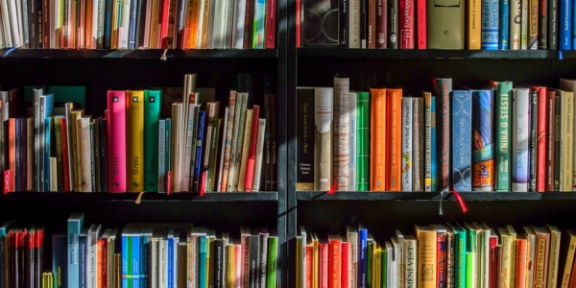
1900-2000
The Black Crow Conspiracy by Christopher Edge – in 1902 the new King’s Coronation has been postponed. Is he really ill, or has something else happened?
Things a Bright Girl Can Do by Sally Nicholls - the fight for women’s freedom will challenge Evelyn, May and Nell more than they ever could believe. As war looms, just how much are they willing to sacrifice?
A Question of Courage by Marjorie Darke – the story tells of life as a suffragette and explores class issues as well.
A Rose from Blighty by Marjorie Darke - follows the same characters into World War One and looks at nursing and hospital life.
A Long Way to Go by Marjorie Darke - is about being a conscientious objector in World War One and the main characters are Black.
Anzac Boys by Tony Bradman - two orphan brothers are encouraged to emigrate to Australia, are used as cheap labour and then join the army and find themselves at Gallipoli.
Conkers and Grenades by Hilary Lee-Corbin - a German spy ring is discovered by children in Bristol in 1916.
The Skylarks' War by Hilary McKay - a family grows up against the harsh backdrop of World War One.
Love and War by Theresa Breslin - a group of teenage friends picnic in 1914 as their lives are about to be turned upside down.
Poppy in the Field by Mary Hooper – Broken hearted Poppy volunteers her nursing skills overseas on the First World War frontline to take her away from home.
Conkers and Grenade by Hilary Lee-Corbin - set in Bristol in 1916, in a world plunged into war, Conkers and Grenades follows Mar and Appy, two boys who discover a spy ring and a plot to assassinate the king and queen.
Kicking Off by Eve Ainsworth - Shy teenager Hettie wants to help the war effort, and signs up to work in the local Dick, Kerr & Co. munitions factory. She helps to make sporting history.
Our Beautiful Game by Lou Kuenzler - a hundred years before the Lionesses, Lily Parr, Alice Woods and their teammates were proudly playing their beloved, exciting and skilful game.
The Rasputin Dagger by Theresa Breslin – a love story set against the back-drop of the days leading to the Russian Revolution.
Medal for Leroy by Michal Morpurgo - inspired by the true story of Walter Tull, professional footballer and the first black office in the British Army.
The Convalescent Corpse by Nicola Slade – Teenage girls start a business and solve a murder in an English village in 1918.
Testament of Youth by Vera Brittain - OK, it’s not historical fiction, it’s biography, but it was so huge when it was published in the 1930s. A young woman’s story of love, loss and the struggle to live in and beyond the First World War.
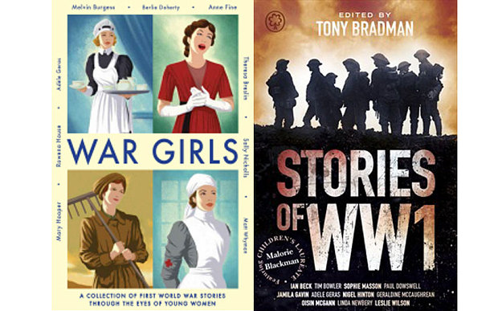
When the Guns Fell Silent by James Riordan – standing amongst the war graves, Jack’s memories take him back to the trenches of 1914.
Make More Noise!: New stories in honour of the 100th anniversary of women’s suffrage by Emma Carroll and Kiran Hargrave - a collection of short stories, from ten of the UK's very best storytellers.
The Four Winds by Kristin Hanna - It is 1934 and in Texas Elsa Martinelli is part of a community struggling with the impact of the Great Depression.
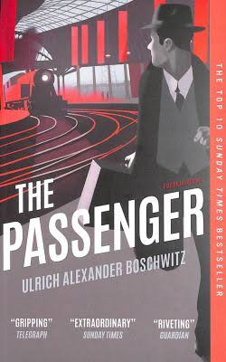
The Passenger by Ulrich Alexander Boschwitz – Otto desperately tries to conceal his Jewish identity as he takes train after train across Germany in a race to escape this homeland that is no longer home.
The Earth is Singing by Vanessa Curtis – a young Jewish Latvian girl tells the story of her life after the Nazis invade. She has promised her disappeared father that she will survive.
Our Castle by the Sea by Lucy Strange – It’s England 1940 and Pet's lighthouse home becomes a terrifying battleground, and her family is torn apart.
Voices: Now or Never: A Dunkirk Story by Bali Rai -Private Fazal Khan journeys from his home in India to the battlefields of the Second World War and makes his way to Dunkirk.
The Endless Steppe by Esther Hautzig – Based on her childhood story of exile to Siberia during World War Two.
The Eagle has Landed by Jack Higgins - World War Two and the German government has given orders to capture Winston Churchill.
Girl in the Blue Coat by Monica Hesse - It’s Amsterdam, 1943 and Hanneke is rebelling against the Nazi invasion of the Netherlands by working the black market.
When We Were Warriors by Emma Carroll – ordinary children living in the extraordinary times of World War Two.
The Swallows’ Flight by Hilary McKay – the stories of children in various places whose lives are caught up in World War Two.
Schindler’s Ark by Thomas Keneally – based on the story of Oskar Schindler, member of the Nazi party and rescuer of Polish Jewish people.
Postcards from No Man’s Land by Aidan Chambers – Jacob’s grandfather’s grave is in the Netherlands as he died in the Second World War Battle of Arnhem. It’s a story of passion and treachery.
Bomber by Paul Dowswell – the crew member of an American Flying Fortress has to make his way back from behind enemy lines. (If you like this book, look for other tales of wartime flying by the same author.)
The Machine Gunners by Robert Westall – Young lads compete to have the most bounty and the discovery of the remains of a German bomber crashed in the woods changes it all. The Kingdom by the Sea and Blitzcat are by the same author and set in the same period.
Wolf Children by Paul Dowswell - It is July 1945 and Berlin is in ruins. Living on the edge of survival in the cellar of an abandoned hospital, Otto and his ragtag gang of kids have banded together in the desperate, bombed-out city.
History teacher Ms Pins says: “When Hitler Stole Pink Rabbit by Judith Kerr is still one of my all-time favourites. It’s based on Kerr’s life and how her family escaped Nazi Germany and came to London. It led me to Anne Frank and a great book called ‘Tell no one who you are’ which is out of print now. In fact I loved this book so much (confession!) I stole it from the library. It never occurred to me that I could just ask for my own copy.
It was Mr Kerr’s favourite too: “I was only drawn to it because we shared a family name but it is so good. I bought a copy for my son recently. It also made me interested in learning languages because of the part where she learns French.”

The Red Ribbon by Lucy Adlington - Rose, Ella, Marta and Carla might in another life have been friends together, but this was Birchwood and now they must try to survive.
Goodnight, Mr Tom by Michelle Magorian - a young evacuee leaves a terrible life and finds a loving home with a gruff, kindly man, but what will happen when he has to return home?
The Book Thief by Markus Zusak – Narrated by death. A young book thief called Liesel in Germany. Fostered, with parents taken away, she lives in a community that death is visiting.
Where Eagles Dare by Alistair Maclean – a secret ops missions to rescue a crashed American general from a remote Gestapo HQ before the Nazis can force him to reveal secret D-Day plans. Force Ten for Navarone is another World War Two thriller by the same author.
Mohinder’s War by Bali Rai - World War II adventure set in occupied France, featuring an Indian RAF pilot.
The Enigma Game by Elizabeth Wein - a German soldier risks his life to drop off the sought-after Enigma Machine to British Intelligence.
The Things We Did for Love by Natasha Farrant - a tale of spies and resistance in a French village in 1944.
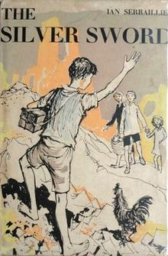
One Day in Oradour by Helen Watts – just after D-Day in 1944, SS troops wiped out an entire French village. 644 men, women and children died that day. Just one child survived.
Diary of a Young Girl by Anna Frank – this is not fiction either, but it should be read. The most famous diary from the Second World War.
Empire of the Sun by JG Ballard – the author’s own memories of Japanese-occupied wartime Shanghai – of war, of starvation and survival, of internment camps and death marches.
The Silver Sword by Ian Serraillier - alone and fending for themselves in a Poland devastated by World War Two, Jan and his three homeless friends cling to the silver sword as a symbol of hope.
This book is popular with our contributors…
Mr Walker, history teacher, “The Silver Sword by Ian Serraillier was brilliant- it really captured the terror of the Nazi regime in Poland but was gripping action.”
Mr Digwood, a lawyer, video gamer, history geek and aeroplane nut says of his favourites: “Without a shadow of doubt The Machine Gunners by Robert Westall. The Silver Sword by Ian Serraillier was also quite a favourite. Both very different accounts of childhood in different aspects of WW2.”
And it was runner up for Mr Kerr, history teacher, who says: “I remember it captivating me as a child but dare not re-read it as an adult in case I find any faults.”

All the Light we Cannot See by Anthony Doerr - a book about a blind French girl and a German boy whose paths collide in occupied France as both try to survive the devastation of World War II.
Arctic Star by Tom Palmer - Winter 1943. Royal Navy recruits are on their first mission at sea as part of an Arctic Convoy sailing to Russia to deliver supplies to the Soviets.
I am David by Anne Holm - David escapes from a prison camp in Eastern Europe and tries to head for Denmark.
Back Home by Michelle Magorian – Rusty has been away for 5 years, evacuated to the USA for the duration of World War Two. The ‘home’ she returns too is strange. You might also like
After the War by Tom Palmer – based on the true story of young Holocaust survivors who were brought to Windermere to begin their post-war lives.
A Cuckoo in the Nest about a young boy in post-war Britain who dreams of being an actor. Also A Spoonful of Jam in which a young girl struggles to relate to her father who has returned from the war and a Just War in which a young boy distracts himself by going to the cinema from the pain of losing his father in the war.
Salt to the Sea by Ruta Sepetys – In early 1945 desperate people trek across Germany to reach the ship Wilhelm Gustloff. 9000 refugees set sail…
A Beautiful Lie by Irfan Master - set in India during the summer of 1947, this book follows the events of the Partition of India through the eyes of Bilal who is looking after his ill father.
Torn Apart by Swapna Harrow – in 1947 two young boys find themselves thrown together as the new India and Pakistan are born. Can the friendship between these two children rise above the tensions between the two countries?
Small Island by Angela Levy – the story of two couples through war and post-war, dreaming of a better life and becoming what is now known as the Windrush generation.
Rani and Sukh by Bali Rai – set between modern-day Britain and the Punjab in the 1950s and 60s, this is a story of tragedy, conflict and love.
The Hypnotist by Laurence Anholt – an Irish professor and a young black boy find their lives cross in the Deep South of the USA in the 1960s.
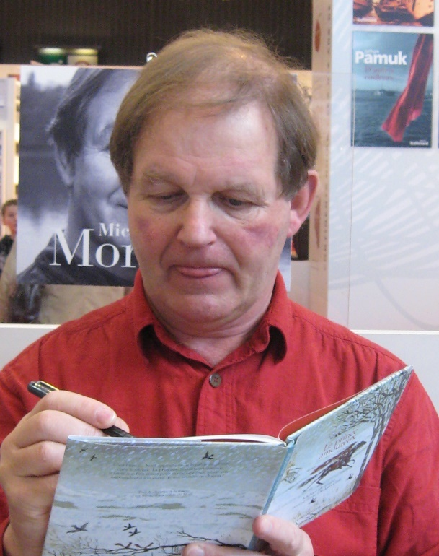
Miss Dyson, a history teacher, recommends The Amazing Story of Adolphus Tips by Michael Morpurgo (pictured left). It’s about a small village that’s used by allied forces to practice for D-day. Lily loses her cat, Adolphus Tips and when she goes looking for him meets all kinds of soldiers.
Michael Morpurgo has written so many historical fiction books for children. He has also been the Children’s Laureate. Just a few more of his books from this period of time are: Private Peaceful, Warhorse and Waiting for Anya.

Girl on a Plane by Miriam Moss – Anna is heading back to boarding school in England after summer with her family in Jordan. Then the plane is hijacked by Palestinian terrorists…
Divided City by Theresa Breslin – it’s Glasgow and it’s the marching season.
Across the Barricades by Joan Lingard - a girl and a boy meet despite hostility from their families and their Protestant and Catholic backgrounds in Northern Ireland of the Troubles. There are sequels!
Dance of the Jakaranda by Peter Kimani – Set in Kenya on the verge of independence from colonial rule in 1963, this is a story of the country and intertwined lives.

“Stories matter. Many stories matter. Stories have been used to dispossess and to malign. But stories can also be used to empower, and to humanize. Stories can break the dignity of a people. But stories can also repair that broken dignity.” author Chimanmanda Adiche (pictured right).

Little Soldier by Bernard Ashley – Kaninda, a child in an East African rebel army, taken to London by aid workers, to a new family and a comprehensive school where urban tribe is against urban tribe.
The Week at World’ End by Emma Carroll – it is 1962, London during the Cuban Missile Crisis, there is a real possibility that the world might end.
The Buddha of Suburbia by Hanif Kurieshi – Teenage Karim is desperate to escape his dull life in 1970s Britain.
Billy Elliott by Melvin Burgess - His mother is dead, and his father and brother are striking miners. Boxing is the man’s sport, but Billy wants to dance.
My Name is Parvana by Deborah Ellis – a tale of a girl dreaming of an education whose life is in danger when the Americans in Afghanistan suspect her of terrorism. Set in the same place by the same author are Mud City, The Breadwinner, The Prison Runner and Parvana’s Journey.
Manchester Happened by Jennifer Nansubuga Makumbi – a collection of short stories about Ugandans who have made their home in Britain.
And finally, Sheffield University lecturer Ms Michallat shared: “I remember the fiction less than the comics which were huge in the 60s and 70s which comprised true war stories of derring-do and popular culture/history like footie/sports tales particular to urban working-class Britain like Alf Tupper, Tough of the Track & Billy's Boots.”
Asterix was mentioned early on in this list and there are many more exceptional cartoon animations that can take you to the past. Why not try Raymond Briggs ‘When the Wind Blows’ or Art Spiegelman’s ‘Maus’?

Make this better!

Lots of people have helped to make this list rich and varied, but we will have missed something wonderful. Please tell us by mailing the Historical Association via enquiries@history.org.uk . We want this list to change and grow, so also please tell us as books, sadly, go out of print and, wonderfully, as new books are published.

Do it yourself?

Seriously! Why not write your own historical fiction? Did you know that the Historical Association has a historical fiction competition every year? You can find out more, including how to enter, by visiting www.history.org.uk. Perhaps it will be just the start and you too will appear in a list like this one day.
